

NOVAC TECHNOLOGY SOLUTIONS

User Manual

Document Version No.: 1.00

Revision History
Version No | Reason For Changes | Author | Approver
0.01 | Draft | Ravi
1.00 | Reviewed & Approved the User Manual | Ravi | NIJANTHAN PL

Table of Contents
1. Introduction 4

2. Reminder mail for outstanding premium policies and auto initiate the policy cancellation 4

Introduction

The document is prepared to understand the reports generated in ZIVA application. This document is being prepared in reference to,
- Guidelines, circulars, instructions and directions released from time to time by Philippines Insurance council.

Functional Overview

To raise an auto reminder mail to customer to pay the outstanding premium for the corresponding policy and to auto initiate policy cancellation for the outstanding policies once the PPW days exceeds / premium validity period.

Auto mail reminder and auto cancel

- The system should automate the process of sending the reminder emails to the respective customer for the outstanding premium policies to prompt customers to pay the premium.
- If the customer fails to pay the full premium on or before the PPW date, the system should automatically initiate prorated cancellations for the corresponding policies on the next day and moved to Policy cancellation Approval bucket. Once the user approves the policy in the policy cancellation, then system should send the cancellation details to the respective customer through email.

Reminder mail triggering.

- The System should send up to three reminder mails to customer on (or) before the PPW date for premium outstanding policies, when except if PPW days is less than 2 days.
- For PPW periods is greater than 44 days, the system should send up to reminder emails based on the proportional ratio of 35%, 70% and 90% of the days before the PPW date
- For PPW periods between 4 and 44 days, the system should send up to reminder emails based on the proportional ratio of 20%, 50% and 80% of the days before the PPW date.
- For PPW periods between 2 and 3 days, the system should send the reminder email from next day of the policy start date up to PPW date.
- For PPW periods less than 2 days, the system should send the reminder email from the policy start date up to PPW date.

Email Body Content.

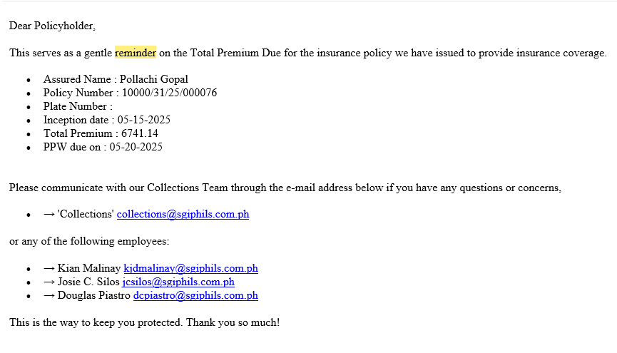

Automated prorate Cancellation

If the customer fails to pay the full premium / Outstanding premium on (or) before PPW date, system should automatically initiate the prorata cancellation for the policies
If the policy premium is not fully collected and the collected premium for the days is less than the PPW date, then system should automatically raise the prorata cancellation for the corresponding policy on the day following of the PPW date.
If the policy premium is not fully collected and the collected premium is more than the PPW date then system should automatically raise the prorata cancellation for the corresponding policy on the day following based on the number of days premium is valid. Refer the below sample example.

